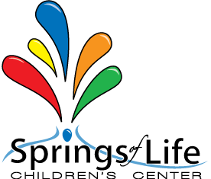

All About Me Questionnaire
TODDLER

Child’s name: ________________________________________________________________________________
My guardian calls me: _______________________________________________________________________
I drink from a: ☐ Bottle AND/OR ☐ Cup
To eat I use a: ☐ Spoon AND/OR ☐ Fork
My favorite food is: __________________________________________________________________________
I am allergic to: ______________________________________________________________________________
I have this medical condition: ______________________________________________________________
I do not like: __________________________________________________________________________________
I usually take a nap between: __________________________ and: ______________________________
My favorite toy is: ___________________________________________________________________________
My favorite activity is: _______________________________________________________________________
This is my first school experience: ☐ Yes ☐ No
My morning routine is: ______________________________________________________________________
My bedtime routine is: ______________________________________________________________________
I handle separation by: ______________________________________________________________________
I am wearing a: ☐ Diaper OR ☐ Pull-ups
I am learning to potty train: ☐ Yes ☐ No
When I am tired my behavior is: ___________________________________________________________
When I am sad my behavior is: _____________________________________________________________
I am afraid of: ________________________________________________________________________________
I am good at: _________________________________________________________________________________

Notes from the guardian: ___________________________________________________________________
_________________________________________________________________________________________________

