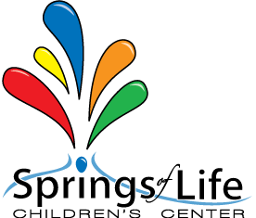

All About Me Questionnaire
PRESCHOOL

Child’s name: ________________________________________________________________________________
My guardian calls me: _______________________________________________________________________
My favorite food is: __________________________________________________________________________
I am allergic to: ______________________________________________________________________________
I have this medical condition: ______________________________________________________________
I do not like to: _______________________________________________________________________________
I DO like to: ___________________________________________________________________________________
My favorite toy is: ___________________________________________________________________________
This is my first school experience: ☐ Yes ☐ No
My morning routine is: ______________________________________________________________________
My bedtime routine is: ______________________________________________________________________
I handle separation by: ______________________________________________________________________
I sometimes have accidents when I: _______________________________________________________
When something is bothering me I may do this: __________________________________________
I am good at: _________________________________________________________________________________
My guardian’s goal for me in preschool is to: _____________________________________________

Notes from the guardian: ___________________________________________________________________
_________________________________________________________________________________________________

